UNIVERSIDADE FEDERAL DA BAHIA
ESCOLA POLITÉCNICA
COLEGIADO DO CURSO DE ENG. ELÉTRICA

Nome do Estudante

Título do Projeto de TCC

Orientador: Prof. Dr. X
Coorientador: Prof. Dr.Y

Salvador-Ba - Brasil
xx de xxxxx de 202x

Seu Nome Completo

Título do TCC

Projeto apresentado ao Curso de Graduação em Engenharia Elétrica da Universidade Federal da Bahia como parte dos requisitos para a obtenção do grau de Engenheiro(a) Eletricista.

Orientador: Prof. Dr. X
Coorientador: Prof. Dr.Y

Salvador-Ba - Brasil
xx de xxxxxxxxx de 202x

Seu Nome Completo

Título do TCC

Projeto apresentado ao Curso de Graduação em Engenharia Elétrica da Universidade Federal da Bahia como parte dos requisitos para a obtenção do grau de Engenheiro(a) Eletricista.

Trabalho aprovado. Salvador-Ba – Brasil, xx de xxxxxxxxxx de 202x:

-------------------------------------------------------
Orientador(a): Prof. Dr. X

-------------------------------------------------------
Prof. Dr. W

------------------------------------------------------
Prof. Dr. X

Salvador-Ba - Brasil
xx de xxxxxxxxx de 202x

Este trabalho é dedicado...

Agradecimentos

Agradeço por ter saúde e ser Bahia...

“Toda criança começa como um cientista nato.”
(Carl Sagan)

Resumo

O resumo deve ressaltar o objetivo, o método, os resultados e as conclusões do documento.
Video provides a powerful way to help you prove your point. When you click Online Video, you can paste in the embed code for the video you want to add. You can also type a keyword to search online for the video that best fits your document.
To make your document look professionally produced, Word provides header, footer, cover page, and text box designs that complement each other. For example, you can add a matching cover page, header, and sidebar. Click Insert and then choose the elements you want from the different galleries.

Palavras-chave: Word, CCEE, Politécnica.

Abstract

This is the english abstract.
Keywords: Word, CCEE, Politécnica.

Lista de Figuras

Fig. 1 Sistema de controle. 25
Fig. 2 Motor 28
Fig. 3 Linha de Transmissão 29

Lista de Tabelas

Lista de Abreviaturas e Siglas

Lista de Símbolos

Sumário

Capítulo 1: Título do Capítulo 1
1.1 Título da primeira Seção 2
1.1.1 Título da subseção. 2
Capítulo 2: Título do Capítulo 4
2.1 Título da primeira seção do segundo capítulo 4
2.1.1 Título da subseção do segundo capítulo. 5
Capítulo 3: Título do Capítulo 6
3.1 Título da primeira seção do terceiro capítulo 6
3.1.1 Título da subseção do terceiro capítulo. 7
Capítulo 4: Título do Capítulo 9
4.1 Título da primeira seção do quarto capítulo 10
4.1.1 Título da subseção do quarto capítulo. 10
Capítulo 5: Título do Capítulo 11
5.1 Título da primeira seção do quinto capítulo 11
5.1.1 Título da subseção do quinto capítulo. 12
Capítulo 6: Título do Capítulo 13
6.1.1 Título da primeira seção do sexto capítulo 13
6.1.2 Título da subseção do sexto capítulo. 14
Referências 15
Apêndice A – Dinâmica do motor de indução 16

Título do Capítulo
Video provides a powerful way to help you prove your point. When you click Online Video, you can paste in the embed code for the video you want to add. You can also type a keyword to search online for the video that best fits your document. To make your document look professionally produced, Word provides header, footer, cover page, and text box designs that complement each other.
For example, you can add a matching cover page, header, and sidebar. Click Insert and then choose the elements you want from the different galleries. Themes and styles also help keep your document coordinated. When you click Design and choose a new Theme, the pictures, charts, and SmartArt graphics change to match your new theme.
When you apply styles, your headings change to match the new theme. Save time in Word with new buttons that show up where you need them. To change the way a picture fits in your document, click it and a button for layout options appears next to it. When you work on a table, click where you want to add a row or a column, and then click the plus sign.
Reading is easier, too, in the new Reading view. You can collapse parts of the document and focus on the text you want. If you need to stop reading before you reach the end, Word remembers where you left off - even on another device. Video provides a powerful way to help you prove your point.

Fig. 1 Sistema de controle.
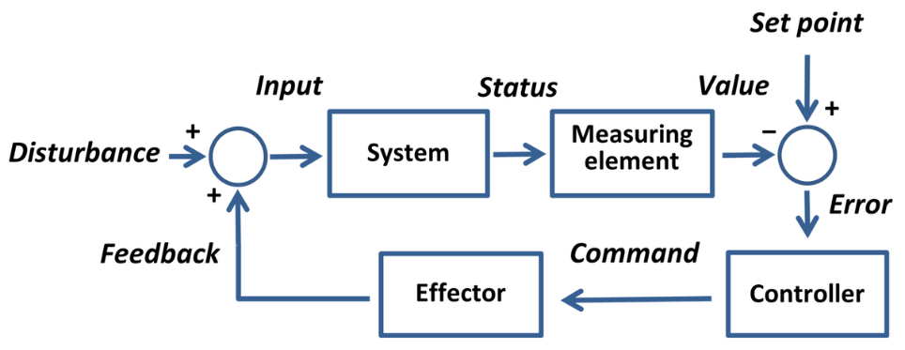
When you click Online Video, you can paste in the embed code for the video you want to add. You can also type a keyword to search online for the video that best fits your document. To make your document look professionally produced, Word provides header, footer, cover page, and text box designs that complement each other. For example, you can add a matching cover page, header, and sidebar.
Click Insert and then choose the elements you want from the different galleries. Themes and styles also help keep your document coordinated. When you click Design and choose a new Theme, the pictures, charts, and SmartArt graphics change to match your new theme. When you apply styles, your headings change to match the new theme.
Save time in Word with new buttons that show up where you need them. To change the way a picture fits in your document, click it and a button for layout options appears next to it. When you work on a table, click where you want to add a row or a column, and then click the plus sign. Reading is easier, too, in the new Reading view.
You can collapse parts of the document and focus on the text you want. If you need to stop reading before you reach the end, Word remembers where you left off - even on another device. Video provides a powerful way to help you prove your point. When you click Online Video, you can paste in the embed code for the video you want to add.

Título da primeira seção
Video provides a powerful way to help you prove your point. When you click Online Video, you can paste in the embed code for the video you want to add.
You can also type a keyword to search online for the video that best fits your document. To make your document look professionally produced, Word provides header, footer, cover page, and text box designs that complement each other.
For example, you can add a matching cover page, header, and sidebar. Click Insert and then choose the elements you want from the different galleries.

Título da subseção.
Video provides a powerful way to help you prove your point. When you click Online Video, you can paste in the embed code for the video you want to add. You can also type a keyword to search online for the video that best fits your document. To make your document look professionally produced, Word provides header, footer, cover page, and text box designs that complement each other.
For example, you can add a matching cover page, header, and sidebar. Click Insert and then choose the elements you want from the different galleries. Themes and styles also help keep your document coordinated. When you click Design and choose a new Theme, the pictures, charts, and SmartArt graphics change to match your new theme.

Título do Capítulo
Video provides a powerful way to help you prove your point. When you click Online Video, you can paste in the embed code for the video you want to add.
You can also type a keyword to search online for the video that best fits your document. To make your document look professionally produced, Word provides header, footer, cover page, and text box designs that complement each other.

Título da primeira seção do segundo capítulo
Video provides a powerful way to help you prove your point. When you click Online Video, you can paste in the embed code for the video you want to add. You can also type a keyword to search online for the video that best fits your document.
To make your document look professionally produced, Word provides header, footer, cover page, and text box designs that complement each other. For example, you can add a matching cover page, header, and sidebar. Click Insert and then choose the elements you want from the different galleries.
Themes and styles also help keep your document coordinated. When you click Design and choose a new Theme, the pictures, charts, and SmartArt graphics change to match your new theme. When you apply styles, your headings change to match the new theme.
Save time in Word with new buttons that show up where you need them. To change the way a picture fits in your document, click it and a button for layout options appears next to it. When you work on a table, click where you want to add a row or a column, and then click the plus sign. Como ilustrado na Fig. 2
Fig. 2 Motor
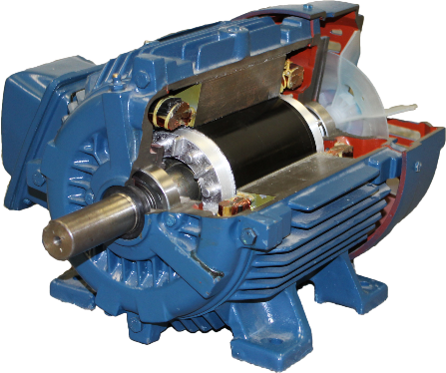

Título da subseção do segundo capítulo.
Video provides a powerful way to help you prove your point. When you click Online Video, you can paste in the embed code for the video you want to add. You can also type a keyword to search online for the video that best fits your document. To make your document look professionally produced, Word provides header, footer, cover page, and text box designs that complement each other. For example, you can add a matching cover page, header, and sidebar.
Click Insert and then choose the elements you want from the different galleries. Themes and styles also help keep your document coordinated. When you click Design and choose a new Theme, the pictures, charts, and SmartArt graphics change to match your new theme. When you apply styles, your headings change to match the new theme. Save time in Word with new buttons that show up where you need them. Como ilustrado na Fig. 2.
Fig. 3 Linha de Transmissão
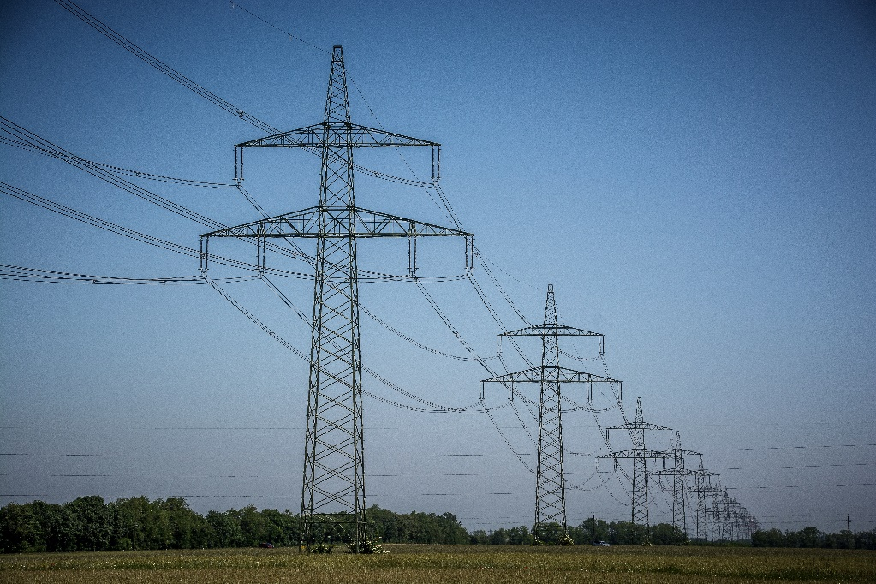

Título do Capítulo
Video provides a powerful way to help you prove your point. When you click Online Video, you can paste in the embed code for the video you want to add. You can also type a keyword to search online for the video that best fits your document. To make your document look professionally produced, Word provides header, footer, cover page, and text box designs that complement each other. For example, you can add a matching cover page, header, and sidebar. Click Insert and then choose the elements you want from the different galleries. Themes and styles also help keep your document coordinated.
When you click Design and choose a new Theme, the pictures, charts, and SmartArt graphics change to match your new theme. When you apply styles, your headings change to match the new theme. Save time in Word with new buttons that show up where you need them. To change the way a picture fits in your document, click it and a button for layout options appears next to it. When you work on a table, click where you want to add a row or a column, and then click the plus sign. Reading is easier, too, in the new Reading view. You can collapse parts of the document and focus on the text you want.

Título da primeira seção do terceiro capítulo
Video provides a powerful way to help you prove your point. When you click Online Video, you can paste in the embed code for the video you want to add. You can also type a keyword to search online for the video that best fits your document. To make your document look professionally produced, Word provides header, footer, cover page, and text box designs that complement each other. For example, you can add a matching cover page, header, and sidebar. Click Insert and then choose the elements you want from the different galleries.
Themes and styles also help keep your document coordinated. When you click Design and choose a new Theme, the pictures, charts, and SmartArt graphics change to match your new theme. When you apply styles, your headings change to match the new theme. Save time in Word with new buttons that show up where you need them. To change the way a picture fits in your document, click it and a button for layout options appears next to it. When you work on a table, click where you want to add a row or a column, and then click the plus sign.
Reading is easier, too, in the new Reading view. You can collapse parts of the document and focus on the text you want. If you need to stop reading before you reach the end, Word remembers where you left off - even on another device. Video provides a powerful way to help you prove your point. When you click Online Video, you can paste in the embed code for the video you want to add. You can also type a keyword to search online for the video that best fits your document.
To make your document look professionally produced, Word provides header, footer, cover page, and text box designs that complement each other. For example, you can add a matching cover page, header, and sidebar. Click Insert and then choose the elements you want from the different galleries. Themes and styles also help keep your document coordinated. When you click Design and choose a new Theme, the pictures, charts, and SmartArt graphics change to match your new theme. When you apply styles, your headings change to match the new theme.

Título da subseção do terceiro capítulo.
Video provides a powerful way to help you prove your point. When you click Online Video, you can paste in the embed code for the video you want to add. You can also type a keyword to search online for the video that best fits your document. To make your document look professionally produced, Word provides header, footer, cover page, and text box designs that complement each other. For example, you can add a matching cover page, header, and sidebar. Click Insert and then choose the elements you want from the different galleries. Themes and styles also help keep your document coordinated. When you click Design and choose a new Theme, the pictures, charts, and SmartArt graphics change to match your new theme.
When you apply styles, your headings change to match the new theme. Save time in Word with new buttons that show up where you need them. To change the way a picture fits in your document, click it and a button for layout options appears next to it. When you work on a table, click where you want to add a row or a column, and then click the plus sign. Reading is easier, too, in the new Reading view. You can collapse parts of the document and focus on the text you want. If you need to stop reading before you reach the end, Word remembers where you left off - even on another device. Video provides a powerful way to help you prove your point.
When you click Online Video, you can paste in the embed code for the video you want to add. You can also type a keyword to search online for the video that best fits your document. To make your document look professionally produced, Word provides header, footer, cover page, and text box designs that complement each other. For example, you can add a matching cover page, header, and sidebar. Click Insert and then choose the elements you want from the different galleries. Themes and styles also help keep your document coordinated. When you click Design and choose a new Theme, the pictures, charts, and SmartArt graphics change to match your new theme. When you apply styles, your headings change to match the new theme.
Save time in Word with new buttons that show up where you need them. To change the way a picture fits in your document, click it and a button for layout options appears next to it. When you work on a table, click where you want to add a row or a column, and then click the plus sign. Reading is easier, too, in the new Reading view. You can collapse parts of the document and focus on the text you want. If you need to stop reading before you reach the end, Word remembers where you left off - even on another device. Video provides a powerful way to help you prove your point. When you click Online Video, you can paste in the embed code for the video you want to add.
You can also type a keyword to search online for the video that best fits your document. To make your document look professionally produced, Word provides header, footer, cover page, and text box designs that complement each other. For example, you can add a matching cover page, header, and sidebar. Click Insert and then choose the elements you want from the different galleries. Themes and styles also help keep your document coordinated. When you click Design and choose a new Theme, the pictures, charts, and SmartArt graphics change to match your new theme. When you apply styles, your headings change to match the new theme. Save time in Word with new buttons that show up where you need them.

Título do Capítulo
Video provides a powerful way to help you prove your point. When you click Online Video, you can paste in the embed code for the video you want to add. You can also type a keyword to search online for the video that best fits your document. To make your document look professionally produced, Word provides header, footer, cover page, and text box designs that complement each other. For example, you can add a matching cover page, header, and sidebar. Click Insert and then choose the elements you want from the different galleries. Themes and styles also help keep your document coordinated. When you click Design and choose a new Theme, the pictures, charts, and SmartArt graphics change to match your new theme.
When you apply styles, your headings change to match the new theme. Save time in Word with new buttons that show up where you need them. To change the way a picture fits in your document, click it and a button for layout options appears next to it. When you work on a table, click where you want to add a row or a column, and then click the plus sign. Reading is easier, too, in the new Reading view. You can collapse parts of the document and focus on the text you want. If you need to stop reading before you reach the end, Word remembers where you left off - even on another device. Video provides a powerful way to help you prove your point.
When you click Online Video, you can paste in the embed code for the video you want to add. You can also type a keyword to search online for the video that best fits your document. To make your document look professionally produced, Word provides header, footer, cover page, and text box designs that complement each other. For example, you can add a matching cover page, header, and sidebar. Click Insert and then choose the elements you want from the different galleries. Themes and styles also help keep your document coordinated. When you click Design and choose a new Theme, the pictures, charts, and SmartArt graphics change to match your new theme. When you apply styles, your headings change to match the new theme.

Título da primeira seção do quarto capítulo
Video provides a powerful way to help you prove your point. When you click Online Video, you can paste in the embed code for the video you want to add. You can also type a keyword to search online for the video that best fits your document.
To make your document look professionally produced, Word provides header, footer, cover page, and text box designs that complement each other. For example, you can add a matching cover page, header, and sidebar. Click Insert and then choose the elements you want from the different galleries.
Themes and styles also help keep your document coordinated. When you click Design and choose a new Theme, the pictures, charts, and SmartArt graphics change to match your new theme. When you apply styles, your headings change to match the new theme.

Título da subseção do quarto capítulo.
Video provides a powerful way to help you prove your point. When you click Online Video, you can paste in the embed code for the video you want to add.
You can also type a keyword to search online for the video that best fits your document. To make your document look professionally produced, Word provides header, footer, cover page, and text box designs that complement each other.
For example, you can add a matching cover page, header, and sidebar. Click Insert and then choose the elements you want from the different galleries.

Título do Capítulo
Video provides a powerful way to help you prove your point. When you click Online Video, you can paste in the embed code for the video you want to add. You can also type a keyword to search online for the video that best fits your document.
To make your document look professionally produced, Word provides header, footer, cover page, and text box designs that complement each other. For example, you can add a matching cover page, header, and sidebar. Click Insert and then choose the elements you want from the different galleries.
Themes and styles also help keep your document coordinated. When you click Design and choose a new Theme, the pictures, charts, and SmartArt graphics change to match your new theme. When you apply styles, your headings change to match the new theme.
Save time in Word with new buttons that show up where you need them. To change the way a picture fits in your document, click it and a button for layout options appears next to it. When you work on a table, click where you want to add a row or a column, and then click the plus sign.

Título da primeira seção do quinto capítulo
Video provides a powerful way to help you prove your point. When you click Online Video, you can paste in the embed code for the video you want to add. You can also type a keyword to search online for the video that best fits your document.
To make your document look professionally produced, Word provides header, footer, cover page, and text box designs that complement each other. For example, you can add a matching cover page, header, and sidebar. Click Insert and then choose the elements you want from the different galleries.
Themes and styles also help keep your document coordinated. When you click Design and choose a new Theme, the pictures, charts, and SmartArt graphics change to match your new theme. When you apply styles, your headings change to match the new theme.
Save time in Word with new buttons that show up where you need them. To change the way a picture fits in your document, click it and a button for layout options appears next to it. When you work on a table, click where you want to add a row or a column, and then click the plus sign.
Reading is easier, too, in the new Reading view. You can collapse parts of the document and focus on the text you want. If you need to stop reading before you reach the end, Word remembers where you left off - even on another device.

Título da subseção do quinto capítulo.
Video provides a powerful way to help you prove your point. When you click Online Video, you can paste in the embed code for the video you want to add. You can also type a keyword to search online for the video that best fits your document. To make your document look professionally produced, Word provides header, footer, cover page, and text box designs that complement each other.
For example, you can add a matching cover page, header, and sidebar. Click Insert and then choose the elements you want from the different galleries. Themes and styles also help keep your document coordinated. When you click Design and choose a new Theme, the pictures, charts, and SmartArt graphics change to match your new theme.

Título do Capítulo
Video provides a powerful way to help you prove your point. When you click Online Video, you can paste in the embed code for the video you want to add. You can also type a keyword to search online for the video that best fits your document. To make your document look professionally produced, Word provides header, footer, cover page, and text box designs that complement each other. For example, you can add a matching cover page, header, and sidebar.
Click Insert and then choose the elements you want from the different galleries. Themes and styles also help keep your document coordinated. When you click Design and choose a new Theme, the pictures, charts, and SmartArt graphics change to match your new theme. When you apply styles, your headings change to match the new theme. Save time in Word with new buttons that show up where you need them.

Título da primeira seção do sexto capítulo
Video provides a powerful way to help you prove your point. When you click Online Video, you can paste in the embed code for the video you want to add. You can also type a keyword to search online for the video that best fits your document.
To make your document look professionally produced, Word provides header, footer, cover page, and text box designs that complement each other. For example, you can add a matching cover page, header, and sidebar. Click Insert and then choose the elements you want from the different galleries.
Themes and styles also help keep your document coordinated. When you click Design and choose a new Theme, the pictures, charts, and SmartArt graphics change to match your new theme. When you apply styles, your headings change to match the new theme.
Save time in Word with new buttons that show up where you need them. To change the way a picture fits in your document, click it and a button for layout options appears next to it. When you work on a table, click where you want to add a row or a column, and then click the plus sign.
Reading is easier, too, in the new Reading view. You can collapse parts of the document and focus on the text you want. If you need to stop reading before you reach the end, Word remembers where you left off - even on another device.
Video provides a powerful way to help you prove your point. When you click Online Video, you can paste in the embed code for the video you want to add. You can also type a keyword to search online for the video that best fits your document.
To make your document look professionally produced, Word provides header, footer, cover page, and text box designs that complement each other. For example, you can add a matching cover page, header, and sidebar. Click Insert and then choose the elements you want from the different galleries.
Themes and styles also help keep your document coordinated. When you click Design and choose a new Theme, the pictures, charts, and SmartArt graphics change to match your new theme. When you apply styles, your headings change to match the new theme.

Título da subseção do sexto capítulo.
Video provides a powerful way to help you prove your point. When you click Online Video, you can paste in the embed code for the video you want to add. You can also type a keyword to search online for the video that best fits your document. To make your document look professionally produced, Word provides header, footer, cover page, and text box designs that complement each other. For example, you can add a matching cover page, header, and sidebar. Click Insert and then choose the elements you want from the different galleries. Themes and styles also help keep your document coordinated. When you click Design and choose a new Theme, the pictures, charts, and SmartArt graphics change to match your new theme. When you apply styles, your headings change to match the new theme.

Referências

ERICKSON, Robert W.; MAKSIMOVIC, Dragan. Fundamentals of power electronics. Springer Science & Business Media, 2007.

CHEN, Jingquan; MAKSIMOVIC, Dragan; ERICKSON, Robert W. Analysis and design of a low-stress buck-boost converter in universal-input PFC applications. IEEE Transactions on Power Electronics, v. 21, n. 2, p. 320-329, 2006.

Apêndice A – Dinâmica do motor de indução

